APPLECROSS SENIOR HIGH SCHOOL

YEAR 11 HUMAN BIOLOGY TEST 1

PART A: Multiple Choice Questions (20 marks)

- The concentration gradient of carbon dioxide in a muscle cell is found to be greater after exercise than before. This would cause:

- The passive movement of carbon dioxide out of the cell
- The passive movement of carbon dioxide into the cell
- The active movement of carbon dioxide out of the cell
- The active movement of carbon dioxide into the cell

- Mitochondria concentration would be highest in which of these cells?

- Nerve cells
- Secretory cells
- Muscle cells
- Red blood cells

- What organelle would you expect to be abundant in enzyme secreting cells:

- Lysosome
- Chloroplast
- Endoplasmic reticulum
- Golgi apparatus

- A series of interconnecting canals transporting fluids has been observed in the cell. These canals are called:

- Mitochondria
- Endoplasmic reticulum
- Centrioles
- Lysosomes

- If a mixture of proteins and glucose is placed in a cellulose bag immersed in water, the glucose will diffuse through the bag but the proteins will not. This is because the bag is:

- A living membrane
- Selectively permeable
- Permeable only to molecule of inorganic origin
- Impermeable to all except large organic molecules

- When viewing cells under the microscope, which of the following is false?

- The higher the magnification, the less cells you see
- When the slide is moved to the right, it appears to move to the left
- Under lower magnification you would see more of the cells in the field of view
- When changing the magnification from 40X to 100X, the field of view is greater

- What is the name of the specialised protein that allows water through the cell membrane:

- Cholesterol
- Peripheral
- Phospholipid
- Aquaporin

- In the plasma membrane, ______________ makes the membrane more flexible:

- Proteins
- Phospholipids
- Cholesterol
- Glycolipids

- Which statement is false:

- Tissues are made up of cells
- The skin is an organ
- Organs are made up of tissues
- Each organ is made up of its own kind of tissue

- Calcium is actively transported out of a cell. Which one of the following statements regarding this situation is true?

- Osmosis stops during active transport of calcium
- The calcium concentration outside the cell is higher than the calcium concentration inside the cell
- The cell membrane is impermeable to calcium
- Calcium is not needed for cellular functioning

- Four microscopes were set up in the laboratory as follows:
Microscope | Objective Lens | Ocular
A | 10X | 5X
B | 20X | 10X
C | 40X | 5X
D | 40X | 10X

When looking at a slide of human tissue, which microscope would you expect to observe the fewest cells?

- A
- B
- C
- D

- Skin is considered an organ because:

- It consists of tissues structurally joined together to perform a specific function
- It is large and covers the entire body
- It is compact to give shape
- It is continuous

- The concentration of a particular ion within a cell is higher than the concentration outside the cell. However, the concentration in the cell is still increasing. This is due to:

- Osmosis
- Diffusion
- Active transport
- Facilitated diffusion

- Oxygen always moves across the plasma membrane by the process of:

- Active diffusion
- Facilitated diffusion
- Osmosis
- Simple diffusion

- The solvent that is usually associated with osmotic pressure is:

- Alcohol
- Fats
- Oxygen
- Water

- Which of the following statements about cells and surface area are correct?

- Increasing the diameter of a cell increases the surface area more than the volume
- Increasing the diameter of a cell increases the volume more than the surface area
- Increasing the diameter of a cell increases the volume but decreases the surface area
- Increasing the diameter of a cell increases its surface area but decreases its volume

Refer to the illustration to answer questions 17 and 18.

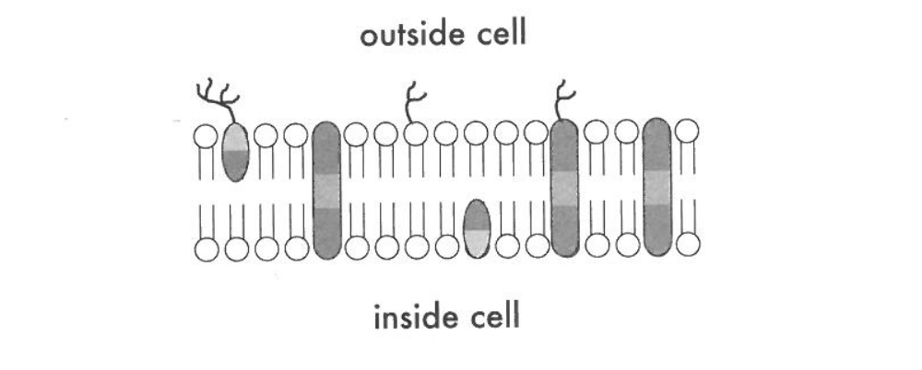
A
B
C
F

D
E

- Which molecule may function in facilitated diffusion?

- A
- B
- D
- E

- Which molecule is both hydrophobic and hydrophilic and aggregates as a bilayer to form the “fabric” of the membrane?

- C
- D
- E
- F

Questions 19 and 20 refer to the information below

Cell | Surface Area (mm²) | Volume (mm³)
1 | 1.70 | 0.135
2 | 0.54 | 0.027
3 | 1.50 | 0.125
4 | 0.06 | 0.001

- The cell that has the greatest surface area to volume ratio is

- Cell 1
- Cell 2
- Cell 3
- Cell 4

- The diffusion of substances would be least efficient into

a) Cell 1
b) Cell 2
c) Cell 3
d) Cell 4


Human Biology 2017

Year 11
Test 1 – Cells and Tissues
Answer Booklet

Student Name: _____________

PART A |  | /20

PART B |  | /20

PART C |  | /10

TOTAL |  | /50

GENERAL INSTRUCTIONS  - Time Allowed: 50 minutes  - Write using a black or blue pen  - You may use pencil to draw diagrams  - Attempt ALL questions  - Scientific calculators may be used | PART A 20 Marks  Consists of 20 Multiple choice questions  PART B 20 Marks  Consists of 5 short answer questions  PART C 10 Marks  Consists of 2 extended answer questions
MULTIPLE CHOICE ANSWER SHEET
PART A

- Use a pencil to fill in the correct letter as shown

1 [A] [B] [C] [D] | 11 [A] [B] [C] [D]
2 [A] [B] [C] [D] | 12 [A] [B] [C] [D]
3 [A] [B] [C] [D] | 13 [A] [B] [C] [D]
4 [[A] [B] [C] [D] | 14 [A] [B] [C] [D]
5 [A] [B] [C] [D] | 15 [A] [B] [C] [D]
6 [A] [B] [C] [D] | 16 [A] [B] [C] [D]
7 [A] [B] [C] [D] | 17 [A] [B] [C] [D]
8 [A] [B] [C] [D] | 18 [A] [B] [C] [D]
9 [A] [B] [C] [D] | 19 [A] [B] [C] [D]
10 [A] [B] [C] [D] | 20 [A] [B] [C] [D]

YEAR 11 HUMAN BIOLOGY – TEST 1

PART B: Short answer questions (20 marks)

- Use the diagram below to complete the table.
(4 marks)
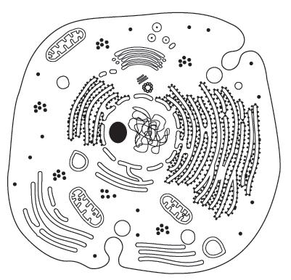
A
B
C
D

Structure Label | Cell Organelle Name  (¹/₂ mark each) | Function  (1/2 mark each)
A

B
(small dots)
C

D

- What is the difference between osmolarity and tonicity?
(2 marks)

- Complete the table by naming the four types of tissues, describing the function of each tissue type and providing a specific example of each tissue type. (8 marks)

Tissue Name | Function | A specific example
Muscular Tissue

Connective Tissue

Epithelial Tissue

Nervous Tissue

- A semi-permeable membrane allows materials to be transported through it in several ways.
What are the differences between passive and active transport?
(2 marks)

- A particular cell was subjected to a number of different treatments. The treatments consisted of immersing the cell in solutions of different ion concentrations.

The appearance of the cells at the beginning of the investigation is shown below


After several minutes in the solutions the following changes were observed

Treatment 1 | Treatment 2` | Treatment 3
 |  | 

- Describe the tonicity of each treatment using appropriate scientific terminology. (3 marks)

Treatment 1:____________________

Treatment 2:____________________

Treatment 3:____________________

- How does the above process differ from diffusion?

(1 mark)

YEAR 11 HUMAN BIOLOGY – TEST 1

PART C: Extended answer questions (10 marks)

- Describe the model of the cell membrane and relate this to its function
(5 marks)

- Explain how active transport enables materials to move through the cell membrane
(5 marks)

END OF TEST

